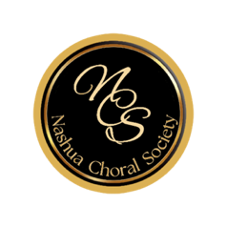

NCS social media policy
2023-2024 Season

NCS will be recording rehearsals and concerts to post on You Tube, and possibly on local TV. We will also post photos on the Website and Facebook. By participating in the group, you agree to the distribution of group images.

There may also be occasions where we would like to take candid photos of individuals for use on social media. Do you give consent for individual photos of you to be posted to You Tube, Facebook, or local TV?

Yes: ____ No: _____

Name:
(Print)

Signed: ________________________________________________________

Date: _________________

