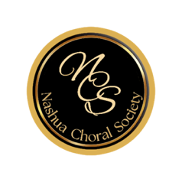
Welcome Singers!

Join NCS for the 2023-2024 season.

Name:

Address:
Street City St Zip

Phone:

Email:

Voice Part:

Emergency Contact:
(please include name, phone number, and relationship)

Dues:
Full Year: $100.00
Fall Semester: $60.00
Scholarship/Assistance: Please contact a Board Member

Music:

How did you hear of us? ___________________________________

Volunteer – NCS appreciates not only your voice but your contribution! Distribute posters, sell tickets, assist with grant proposals. Talk to any Board member to volunteer.

